1. As a Performance Tester, why it is so important for me to know about Software Architecture.
2.  Maybe for a Manual Tester, it is not that important.
3. Consider the following situation.  
   
4. In the above case, Mark is the one who placed and order and then to identify the late serving, he went into the kitchen to understand the real issue.
5. But in Performance Testing, we have Performance Tester and instead of Kitchen, we have architecture of an app under test.   
   In the following slide, the order is to click the “Sign In” button instead of placing order for burger in a restaurant.   
   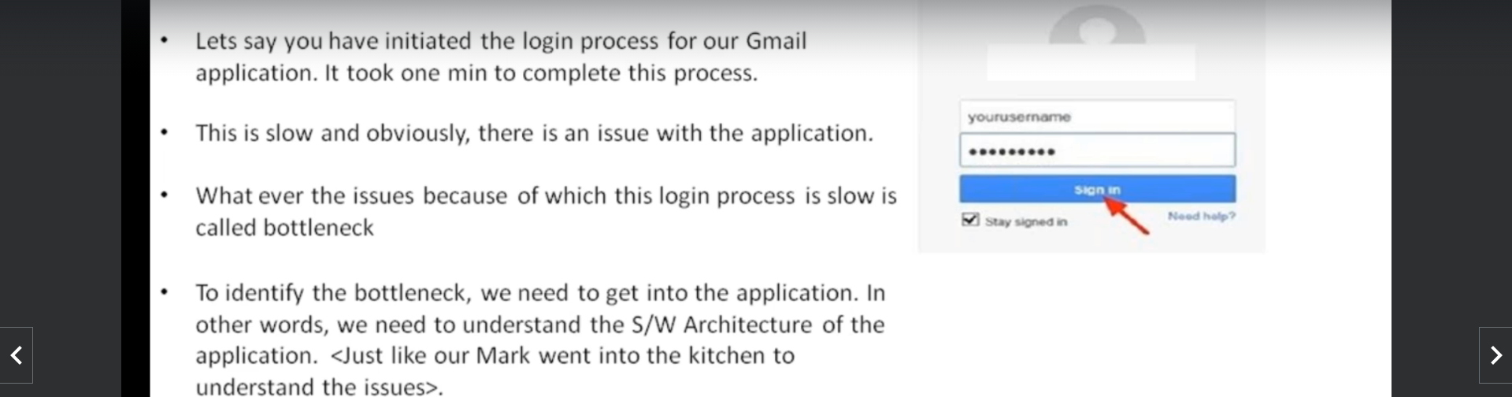
6. So, as a Performance Tester, you have to identify the bottleneck.   
   To identify the bottleneck, you have to monitor the system.   
   To monitor a system, you need to understand its architecture.